EXTENSION OF
CONSULTANCY SERVICES AGREEMENT
BETWEEN ZEDIANT AND INFOMEDIA
This Extension of the Consultancy Services Agreement dated 10 May 2019 is effective as of 1 May 2023 ("Extension") by and between:
INFOMEDIA LTD (ACN 63 003 326 243) with its registered office located at Level 5, 155 Clarence Street, Sydney, NSW 2000, Australia (“Client” or “Infomedia”)
AND
ZEDIANT TECHNOLOGIES PRIVATE LIMITED Corporate Identify U72900WB2017 PTC222317 with its registered office located at 37, Pramanik Ghat Road, Block – B Flat D3 Kolkata West Bengal India 700036 (“Consultant”)
WHEREAS the parties hereto entered into the Consultancy Services Agreement effective 10 May 2019 and the Statement of Work in Annexure 1 was extended to 30 April 2023 ('the Agreement")
IT IS NOW AGREED THAT subject to the terms and conditions of this Extension, the parties wish amend and to extend the Agreement and the Statement of Work in Annexure 1 term under the following conditions.
- Amendments to Annexure 1 SOW
  - The section 1. Details is deleted and replaced with the following
- DETAILS
Effective Date 1st May 2019
Main business contacts Infomedia – Andrew Selim aselim@infomedia.com.au
Zediant – Jayanta Chatterjee jay@zediant.com
Invoice Recipient Andrew Selim aselim@infomedia.com.au with a copy to accounts-syd@infomedia.com.au
Minimum Term 8 years from the SOW Effective Date to 30 April 2027 with two further renewal periods of 12 Months each at Infomedia’s discretion.
- This Extension incorporates by reference all non-conflicting terms of the Agreement. In the event of any inconsistency between this Extension and the Agreement, the terms of this Extension shall take precedence over the Agreement.

EXECUTION
Each Party hereby confirms its acceptance of the terms and conditions of this Extension by having its authorised representative sign below on behalf of the designated party.

For and on behalf of For and on behalf of
Zediant Technologies Private Limited Infomedia Ltd

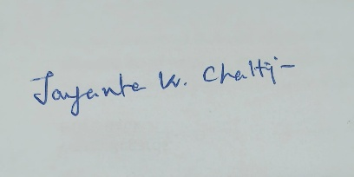
----------------------------------- -----------------------------------
Name: Jayanta Kr. Chatterjee Daniel Wall

Title: Director. Company Secretary

Date: 05/06/2025. Date:

